**Project: Car Price Prediction**

**Name :** Dhiwagar K  
**Batch :**  RP-36 (May 2025)  
**Roll No :** B2025047210

**1. Data Cleaning & Transformation**

* Removed irrelevant ID/index columns.
* Standardized column names for consistency.
* Converted data types (Year, Price, Mileage, Engine Size).
* Treated missing values in Mileage, Engine, and Fuel Type.
* Extracted **Year, Month, Quarter** for time-based trends.
* Added calculated features such as **Car Age**.

**2. DAX Functions**

* **SUM, AVERAGE, DISTINCTCOUNT** → Core aggregations.
* **CALCULATE + FILTER** → Segmented analysis (e.g., Diesel cars, high-value cars).
* **DATEADD** → Year-over-year comparison.
* **IF** → Classified cars as Premium/Standard.
* **RANKX** → Brand ranking by price.

**3. Dashboard Design**

* **KPIs:** Total Price, Average Price, Car Count, Brand Count.
* **Visuals:** Bar (Fuel Type), Line (Yearly Trend), Pie (Transmission), Table (Top 10 Models).
* **Interactivity:** Slicers, Drill-through, Bookmarks for analysis views.

**4. Insights**

* **Brand Impact:** Premium brands like BMW and Audi dominate pricing.
* **Fuel Preference:** Diesel strong at present; EVs show future growth.
* **Transmission Shift:** Automatics priced higher, indicating rising demand.
* **Mileage Factor:** Cars with lower mileage retain stronger resale value.
* **Year Trend:** Stable overall, with noticeable peaks in 2005 and 2020.

**Creative Portfolio Style (For Resume / GitHub Showcase)**

**Car Price Prediction – Power BI Project**

🔹 **About the Project:**  
Built an interactive dashboard to predict and analyze car prices using **Power BI**. The focus was on **data cleaning, transformation, DAX measures, and insightful visualizations**.

**Data Preparation**

* Cleaned and transformed raw car dataset.
* Standardized naming & formatting.
* Created custom fields like **Car Age** for deeper insights.

**Dashboard Features**

* **KPIs:** Total & Average Price, Cars Count, Unique Brands.

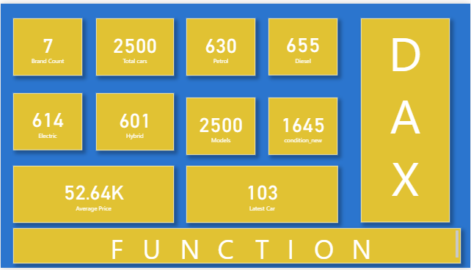

* **Visuals:**
  + Bar → Price by Fuel Type
  + Line → Price Trends (Year-wise)
  + Pie → Transmission Split
  + Table → Top 10 Models
* **Interactive Tools:** Slicers (Year/Fuel/Transmission), Drill-through navigation, Bookmarks for multiple views.

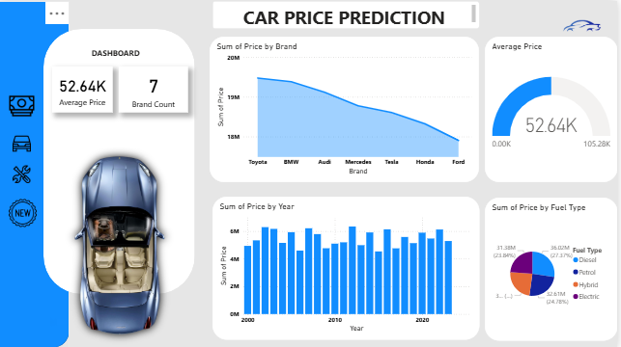

**Key Takeaways**

Premium brands dominate (BMW, Audi).  
 Diesel leads today, EVs growing fast.  
 Automatics priced higher → market shift.  
 Low mileage = better value.  
 Prices peaked in **2005 & 2020**.